[](http://www.chafyngrove.co.uk/)

**CHAFYN GROVE SCHOOL**

**SALISBURY**

**Estates Manager**

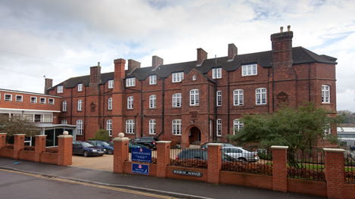

**CHAFYN GROVE SCHOOL**

Chafyn Grove is a thriving day and boarding prep school having approximately 200 boys and girls aged between three and thirteen years.

Chafyn Grove School is situated on the edge of Salisbury within 10 acres of land. The site has excellent academic facilities, with two large Science Labs, a superb Creative Arts Centre, impressive sports hall, heated outdoor pool, large astro hockey pitch and two all-weather tennis/netball courts.

The school provides a first class and broad-based education in which excellent teaching in the classroom is combined with the opportunity for children to develop their talents in music, art, drama, sport and outdoor pursuits. Academic standards are high across the ability range of the children; the School has a strong record of scholarship and Common Entrance success, as well as sending several pupils to Salisbury’s grammar schools at 11. Cricket, tennis, athletics and swimming are the principal summer sports. Rugby, hockey, netball and squash are played in the winter terms. We are particularly strong at Hockey, with many teams regularly making the national prep school finals. Regular plays, concerts and art exhibitions confirm our commitment to the creative side of the children.

Our aim is to provide a relaxed but purposeful environment in which children can flourish, and in which each child is valued as an individual, yet can also experience the invaluable lessons of teamwork and community life. The school takes pride in the good manners and politeness of the children. Discipline is firm but kind, and is based on mutual respect between children and staff.

**Main Purpose:**

The Estate Manager will be an experienced ‘hands on’ manager who will lead a small team of staff in the completion of day to day maintenance tasks and H&S management. The post holder will possess strong project management skills to ensure the timely delivery of multiple projects within budget.

The ideal candidate will be qualified (or working towards a qualification) in health and safety management and be competent in the use of IT systems, management of staff and budgets and have experience in the implementation of safe systems of work.



**

**JOB DESCRIPTION**

**Post:** Estates Manager

**Reports To:** Bursar, Headmaster

**Responsible For:** Estate Workers (full and part time) and Head of Grounds

**Hours of Work:** 45 hours a week, Monday to Friday. Flexibility required.

**Annual Leave:** 28 days paid leave including all Public and Bank Holidays per annum

**Salary:** £45,000 - £50,000 dependent on experience and qualifications

**Benefits of Employment:**

* Competitive salary
* AVIVA Support Staff Pension Scheme including Life Assurance (4x death in service) and Income Support as part of an Employee Assistance Programme.
* Lunch and all refreshments provided free of charge during term time.
* Paid lunch break
* All PPE and work clothing provided
* Free parking
* Discounted gym membership with Parkwood Leisure, Salisbury
* Flexibility to manage own hours across a working week.
* Work mobile phone contract.

**Main Purpose:**

* To effectively line manage the estates and grounds team.
* To project manage all response, planned maintenance and capital expenditure activities at the school.
* To work closely with the Bursar and Head to ensure the effective operation of the school buildings, grounds and resources.
* To provide ‘hands on’ support to the Estates and Grounds staff to ensure that targets for the completion of any projects are met.
* To oversee the efficient day to day operation of the school premises in co-ordination with Pupil, Teachers and Support Staff activities.
* To provide effective management of all H&S systems, inspection and legislative requirements and to organise training, where required.

**Duties and Responsibilities**

**Department Management**

* To line manage the Estates team and Head of Grounds.
* To carry out annual appraisal reviews and work with HR and the Bursar to deal with any

personnel issues, as required.

* To work closely with the Domestic Manager and staff.

# School Estate Management

* To manage and deliver cost effective and timely reactive and planned maintenance programmes, acting as the Clerk of Works to make recommendations, prepare briefs and specifications to ensure these are delivered within budget and to the high standards required.
* To assist the Bursar with the setting of the estates and grounds annual budgets. Manage the department budgets effectively and in line with the annual budget. Allocate funds accordingly, obtain quotations and ensure value for money.
* To oversee and be responsible for the efficient procurement and tendering of consultants, contractors and suppliers.
* Monitor and prioritise maintenance tasks ensuing that all requests are logged on to the school system and carried out in a professional, cost effective and timely manner.
* Effectively communicating to relevant staff to ensure the smooth operation of the estates department.
* Oversee the completion of the School’s annual capital expenditure programme and report on progress to the Bursar and Governors.
* Ensure all statutory checks and tests are carried out in a timely manner and all issues are dealt with swiftly.
* Management of the School swimming pool including the provision and safeguarding of chemicals, daily testing and preparing risk assessments for use.
* Manage the use, hire, maintenance and training for the School minibuses within budget to comply with all legislative and insurance requirements.
* Oversee and assist with the driving of the mini bus services for pupils, as required.
* Preparing and clearing areas for School functions. lettings and events, assisting with the moving of furniture and equipment, as required.
* Oversee the management of the School car parks and CCTV system to ensure compliance.
* To draw up an annual schedule with the Bursar detailing repairs, minor projects, ongoing maintenance and ground work to be carried out during the course of each term and school holidays within the budget allocated.
* To manage the utility contracts and heating system timers to monitor usage and expenditure.
* To attend school emergencies during the school day and outside office hours including weekends, as required.
* To work with the Bursar to improve the School’s sustainability and environmental performance, including energy consumption.
* To assist the Bursar with the renewal of the School insurance policies for the estate and dealing with insurance claims as and when they arise.

**Maintenance:**

* To be responsible for the maintenance, upkeep, and preparation of all School buildings, grounds, gardens, playing fields, car-parking areas and road accesses.
* Manage and oversee the school refuse collection and contracts.
* Maintain a sufficient stock of maintenance and grounds materials and equipment dealing with and checking deliveries.
* Carrying out preparation work for external contractors engaged on minor work programmes including coordinating and overseeing work on site.

**Grounds**

* To work with the Head of Grounds to ensure that sports areas are ready for time-tabled or match use as determined by the Director of Sport.
* To ensure that all grounds maintenance equipment and vehicles are kept in a good state of repair, are properly serviced, are used always in accordance with operating instructions, and are adequately secured when not in use.
* To ensure that all grounds maintenance buildings are locked-up and secure whenever unsupervised.
* Line management of the Head of Grounds and work closely together to deliver an effective plan for maintenance regimes and day to day upkeep of the site and grounds.

**Health and Safety**

* To take the lead role as the Health and Safety Officer for the school and to manage the H&S at work regulations including any other statutory or inspection requirements.
* To be responsible for the creation and editing of the School’s Health and Safety Policy ensuring that the Bursar and Head are updated on any compliance issues and issuing this to the Board of Governors for approval at the start of each Autumn term.
* To carry out a termly health and safety inspection and to implement an action plan to effectively manage any areas of concern.
* Ensuring that all health and safety rules are adhered to and that all staff using equipment are properly competent and trained to do so.
* To ensure that a comprehensive programme of Health and Safety training is delivered to all staff, as necessary.
* Ensure that risk assessments are up to date for the whole school and to implement any action plans as required following consultation with the appropriate stakeholders.
* Attend any meetings as required and to chair and take minutes of the termly H&S meetings.
* To ensure that safe working practices are employed and that all staff are properly trained and competent in the operation of any equipment put into their charge.
* To report incidents to the HSE/RIDDOR as necessary.
* To liaise with the HSE or other statutory departments, as required.
* To manage the register of asbestos and carryout R&D surveys for maintenance and capital project work as required.
* To follow and to contribute to the Schools Disaster Recovery Plan.
* Work closely with the School Fire Marshall to oversee the weekly testing of the fire alarm system and ensure regular fire drills are carried out and recorded.
* Plan annual fire training for staff, as required.

**Security**

* Assume overall responsibility for the security of the School buildings and premises and ensure appropriate security measures are in place for the safeguarding of staff and pupils and compliance with all insurance requirements.
* Work closely with the Head of Boarding to monitor and assist with locking up and securing the school and estate both during term time and school holidays.
* Develop and manager CCTV, access control and other security measures to prevent theft or

damage to the School property.

* To act as a designated on-call key holder, providing out of hours and emergency response

to alarms or incidents.

* To work with the Bursar to review and oversee business continuity management in the case of emergencies.

**Lettings**

* To work closely with the Bursar to manage the preparation for residential lets.
* To be the main point of contact and assist lets during school holidays.
* Assist with term time lets, as required.

**General Duties**

* Ensure that the safety and welfare of the pupils is paramount. Follow rigorously the advice given by the DSL (Designated Safeguarding Leader) and the instructions in the Chafyn Grove Safeguarding Policy.
* Contribute to the overall ethos, mission and aims of the School.
* To attend all School inset days and training.
* To comply with the School’s code of conduct agreement and interaction with pupil’s policy.
* Uphold the School policies and rules.
* Appreciate and support the roles of all support staff and teachers.
* Attend and participate in relevant events and meetings during the evening or weekend, as required.
* Work in a co-operative, diplomatic and flexible manner.
* To participate and support the School’s appraisal of employees.
* Occasional evening and weekend working will be required, with time off in lieu awarded.
* Undertake any duties or activities as reasonably required by the Bursar or Headmaster to fulfil the requirements of this role and to contribute to the normal expectation and tradition of an independent boarding school.

**Person Specification**

|  |  |  |
| --- | --- | --- |
|  | **Essential** | **Desirable** |
| **Qualifications** | GCSE Maths and English – grade A – C.  Willing to work towards NEBOSH or equivalent qualification.  Hold a full valid driving licence with Category D1 and access to a vehicle. | A professional qualification in Building Services, QS, BS or trade related training and qualifications.  Child Safeguarding Training.  First Aid training.  MIDAS mini bus training. |
| **Experience** | Experience in managing a busy estates/maintenance department and team.  Experience in H&S management.  Experience of setting and managing budgets.  Experience in project management.  Good delegation and line management skills. | Competent in a particular maintenance related trade.  Experience in building regulations and construction.  Previous experience of working in a school. |
| **Knowledge and skills** | Good management and organisation skills with the ability to multi task and adapt to changing priorities.  Good IT skills using Microsoft Word, Excel and Outlook.  The ability to use general maintenance equipment safely and correctly.  To be willing and able to drive a minibus for school trips and morning bus collections.  Excellent written and verbal communication skills. |  |
| **Personal skills and aptitude** | Ability to form positive working relationships with staff at all levels throughout the school and the wider community.  Excellent interpersonal and team management skills.  Self-motivated and enthusiastic with the ability to motivate others.  A hands-on attitude with the ability to complete multiple tasks, prioritise and go that extra mile.  Ability to solve problems, stay calm and work under pressure.  Good sense of humour and communication skills.  Commitment to promoting and safeguarding the welfare of children and young persons. |  |

*The School is fully committed to safeguarding and promoting the welfare of children and young people and expects all staff and volunteers to share this commitment.*

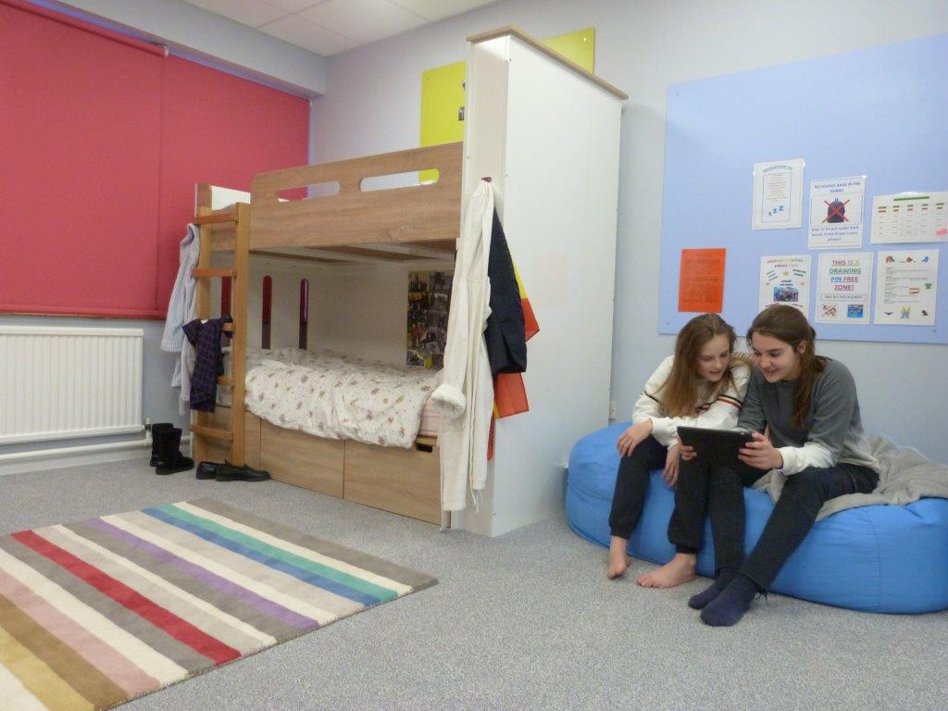

**HOW TO APPLY**

Please contact the school office on 01722 333423 or email [recruitment@chafyngrove.co.uk](mailto:recruitment@chafyngrove.co.uk) or download an application pack from the school website: [www.chafyngrove.co.uk](http://www.chafyngrove.co.uk).

The application form should be returned to Mrs Katie Straker, HR & Compliance Officer via e-mail or post with a short covering letter explaining the reason that you are applying for the role.

When completing the application please ensure your supporting statement reflect the criteria set out in these documents by showing how your experience and skills apply to the role.